This Vista Guide will show you how to set up your PC for your broadband connections

Step 1. On your desktop click on Start then click on Control Panel

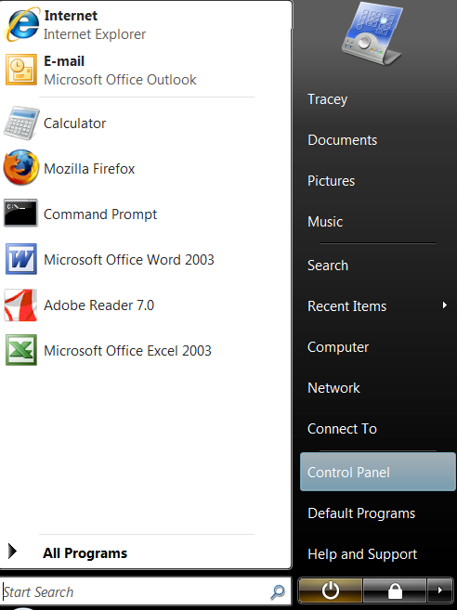

Step 2. Click on Classic View on the left side of screen & Click on
Network and Sharing Center

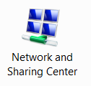

Step 3. In Local Area Connection Click on View Status

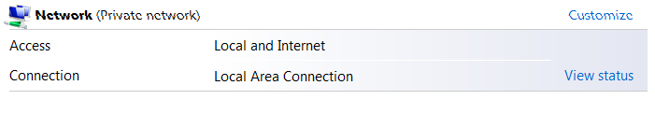

Step 4. In Local Area Connection Click on Properties & Continue

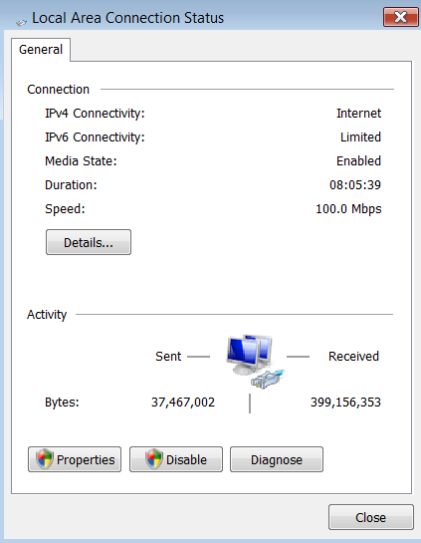

Step 5. Click on Internet Protocol Version 4 (TCP/IPv4) & Click on Properties

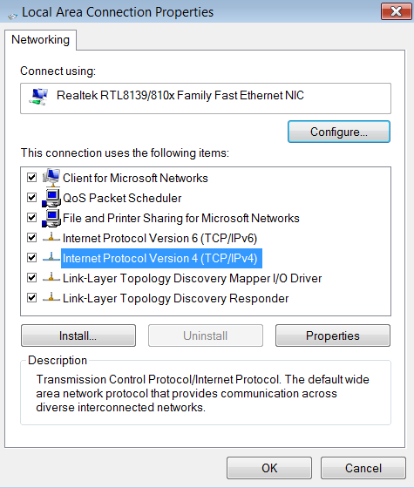

Step 6. Click on Use the following IP address

Step 7. Click on Use the following DNS server addresses.

Step 8. Input the following Information

- IP Address: 172. . .
- Subnet Mask: 255.255.255.252
- Default Gateway 172. . .

- Preferred DNS Server: 78.155.251.1
- Alternate DNS Server: 78.155.250.1

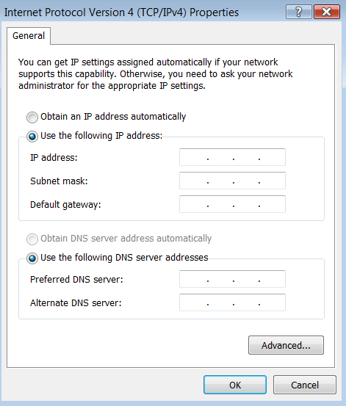

Step 9. Click ok When all Information Entered

Step 10. Click OK then Close

Step 11. Now click on Internet Explorer & surf the World Web!!!



If you have any problems with setting up your PC someone will talk you through the process, or email us on broadband@nwewireless.com

Calling from the North 028 71351999: Calling from the South 048 71351999

