This Windows 7 Guide will show you how to set up your PC for your broadband connections

Step 1. On your desktop click on Start then click on Control Panel

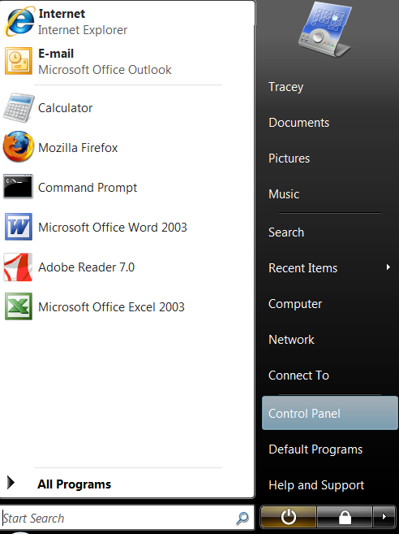

Step 2. Click on Network & Internet

Step 3. Click on Network and Sharing Center

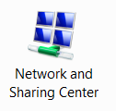

Step 4. Select change adapter settings on the left side of the screen

Step 5. Look for Local Area Connections and Right Click.
(Ensure that this is enabled if not right click & click on enable)

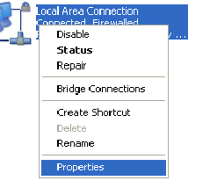

Step 6. When Right clicked choose Properties.

Step 7. Click on Internet Protocol Version 4 (TCP/IPv4) & Click on Properties
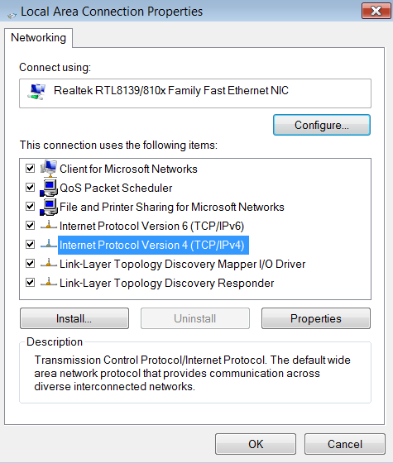

Step 8. Click on Use the following IP address

Step 9. Click on Use the following DNS server addresses.

Step 10. Input the following Information

- IP Address: 172. . .
- Subnet Mask: 255.255.255.252
- Default Gateway 172. . .

- Preferred DNS Server: 78.155.251.1
- Alternate DNS Server: 78.155.250.1

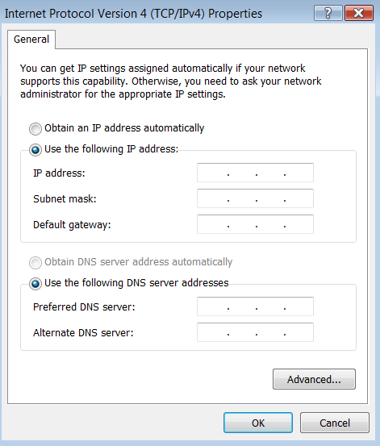

Step 11. Click ok When all Information Entered

Step 12. Click OK then Close

Step 13. Now click on Internet Explorer & surf the World Web!!!



If you have any problems with setting up your PC someone will talk you through the process, or email us on broadband@nwewireless.com

Calling from the North 028 71351999: Calling from the South 048 71351999

