This XP Guide will show you how to set up your PC for your broadband connections

Step 1. On your desktop click on Start then click on Control Panel

Step 2. Click on Network / Internet Connections

Double-click

Step 3. Look for Local Area Connections and Right Click
(Ensure that this is enabled if not right click & click on enable)

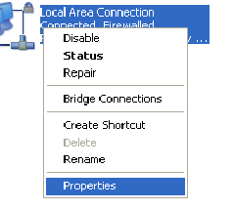

Step 4. When Right Clicked Click on properties

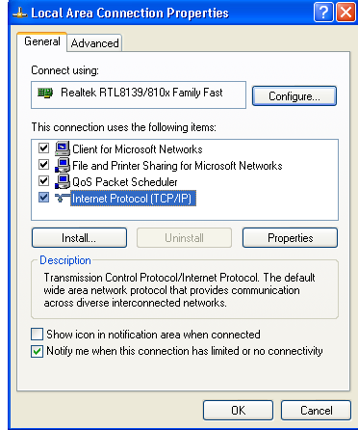

Step 5. Highlight Internet Protocol(TCP/IP)
Step 6. Click on Properties

Step 7. Click on Use the following IP Address &
Click on Use the following DNS server addresses.
Step 8. Input the following Information

- IP Address: 172.____. ____. ____
- Subnet Mask: 255.255.255.252
- Default Gateway 172.____._____.____

- Preferred DNS Server: 78.155.251.1
- Alternate DNS Server: 78.155.250.1

Step 9. Click OK

Step 10. Click OK then Close

Step 11. Now click on Internet Explorer & surf the World Web!!!



If you have any problems with setting up your PC someone will talk you through the process, or email us on broadband@nwewireless.com

Calling from the North 028 71351999: Calling from the South 048 71351999

